“THEY REALLY DON’T LEAK!!”

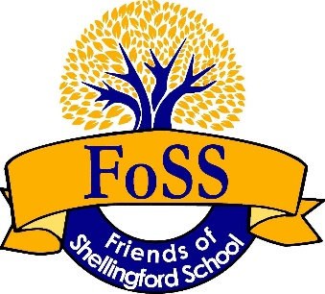

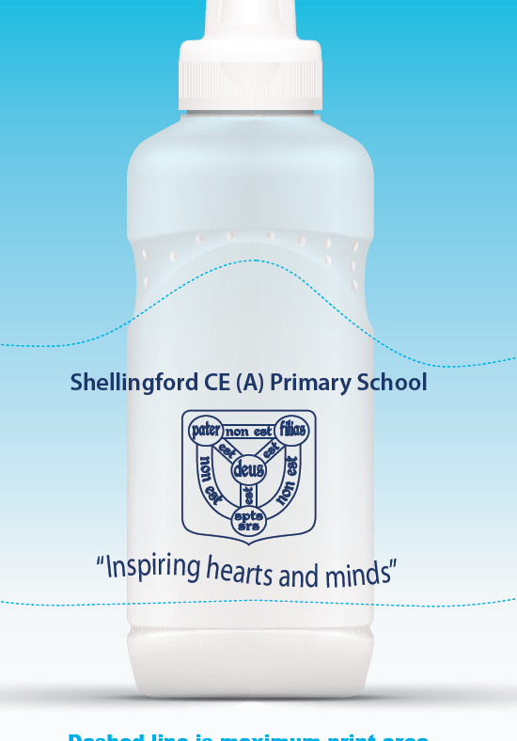

Our Non-spill sports cap water bottles with school logo are really sturdy and long lasting!
They come with a lid, but spare lids are available to purchase separately.

Water bottles are on sale throughout the year via the school office, FoSS Committee members and sometimes after school or during special events.

If you would like to order them please speak to a Committee Member or fill in the form and e-mail it to: friendsofshellingfordschoolpta@gmail.com

 |  | Quantity required
1 bottle | £3.00
2 bottles | £5.00
1 lid | £0.60

Name of the child/children |  | Class
Parent Name |  | Date

There are different way to pay us – please put an X to indicate your choice:

 | Bacs Payment to FoSS Account:  Sort: 30-93-18  Acc: 00710605 | Please make payment upon submitting your order. Once monies are received we will deliver your bottles
 | Cash | please put the right amount in an envelope with your name and hand over when receiving the bottles
 | Cheque made payable to: Friends of Shellingford School | please place the cheque in an envelope with your name and hand over when receiving the bottles

